**Quiz App Android Project Report**

**GitHub Link:** <https://github.com/lakmina456/Quiz_App>

(Project Files + Screenshots, Source Code included Word Document)

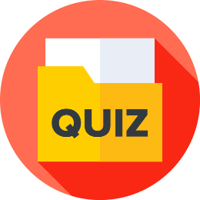

**Name: I.D.I.L Senavirathna**

**Registration Number: ICT/19/20/140**

**Index Number :5073**

**ICT3214 - Mobile Application Development**

1. 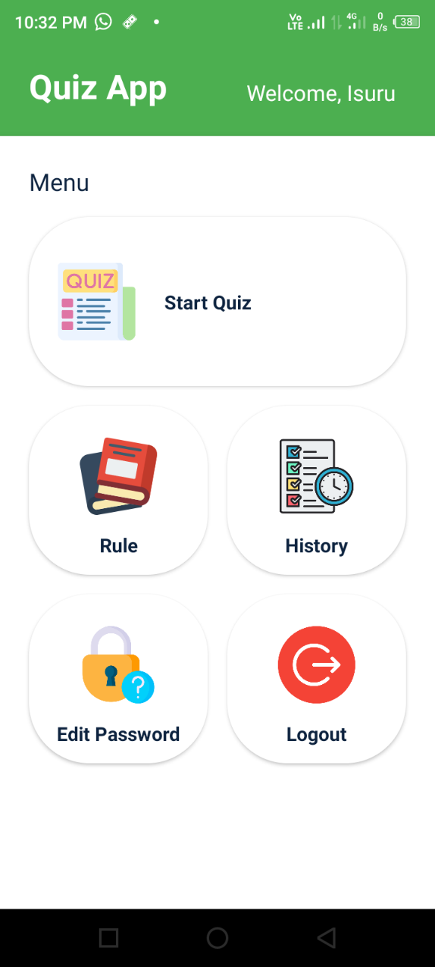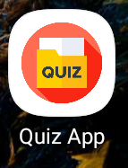**UI Design**

Main Menu

Buttons

User name

App Icon

1. **AndroidManifest.xml**

<?xml version="1.0" encoding="utf-8"?>  
<manifest xmlns:android="http://schemas.android.com/apk/res/android"  
 package="com.example.QuizApp">  
  
 <application  
 android:allowBackup="true"  
 android:icon="@drawable/icon"  
 android:label="Quiz App"  
 android:roundIcon="@drawable/icon"  
 android:supportsRtl="true"  
 android:theme="@style/Theme.QuizForFun">  
 <activity android:name=".OperationalOrSecurityQuizActivity"/>  
 <activity android:name=".FinalResultActivity" />  
 <activity android:name=".MobileQuizActivity" />  
 <activity android:name=".EditPasswordActivity" />  
 <activity android:name=".HistoryActivity" />  
 <activity android:name=".RuleActivity" />  
 <activity android:name=".QuizOptionActivity" />  
 <activity android:name=".RegisterActivity" />  
 <activity  
 android:name=".LoginActivity"  
 android:exported="true">  
 <intent-filter>  
 <action android:name="android.intent.action.MAIN" />  
 <category android:name="android.intent.category.LAUNCHER" />  
 </intent-filter>  
 </activity>  
 <activity android:name=".MainActivity" />  
 </application>  
  
</manifest>

1. **Java Files**

All Java files codes store in GitHub link folders

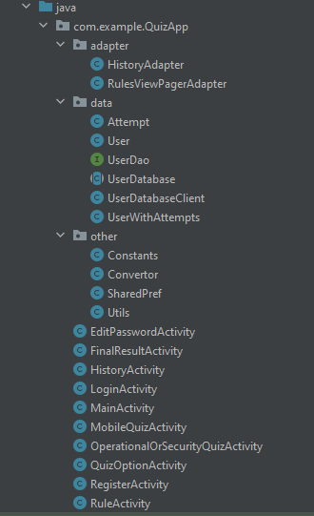<https://github.com/lakmina456/Quiz_App/tree/main/app/src/main/java/com/example/QuizApp>

1. **Design XML Files**

All Xml Design files codes store in GitHub link folders

<https://github.com/lakmina456/Quiz_App/tree/main/app/src/main/res/layout> 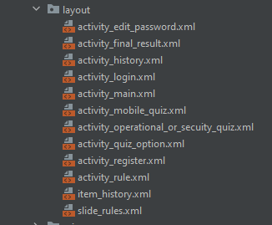

1. **Screenshots**

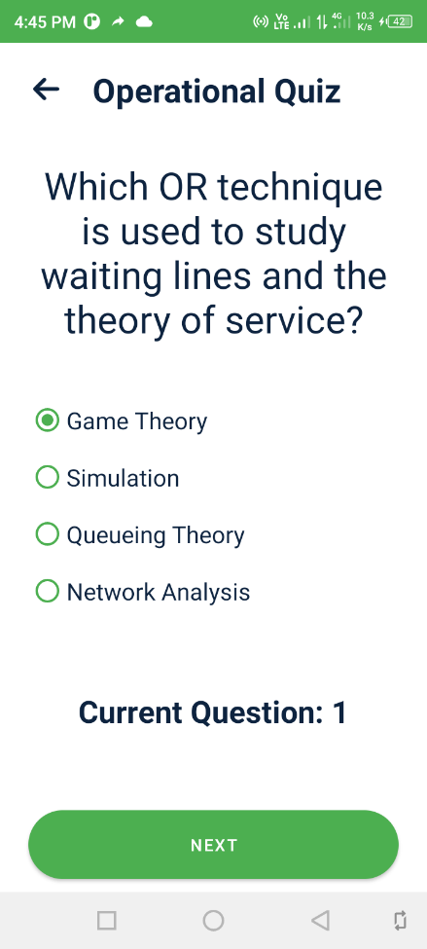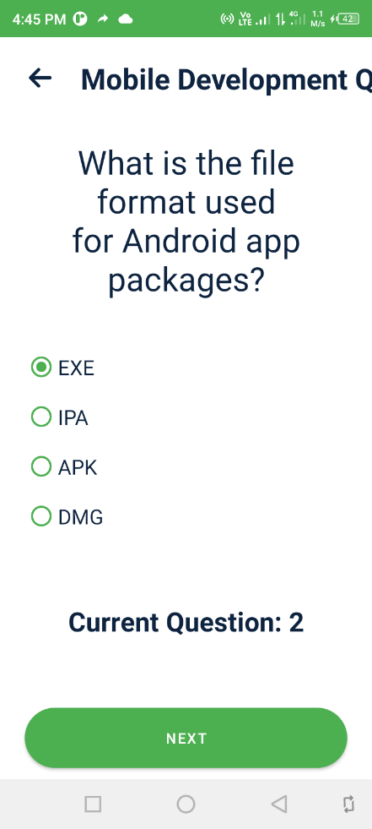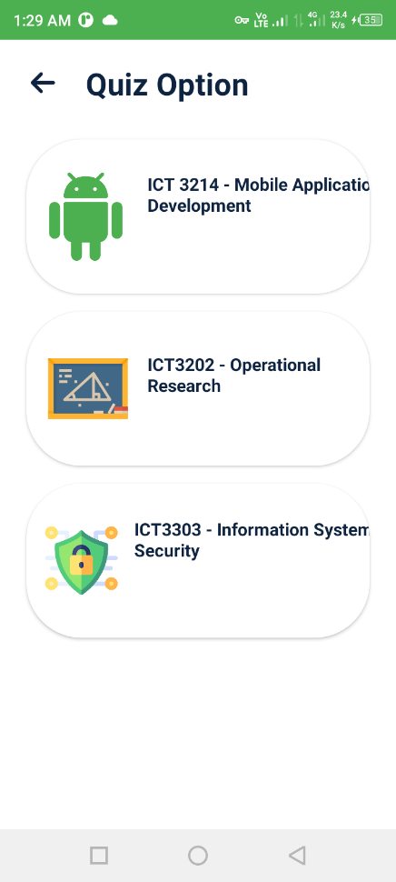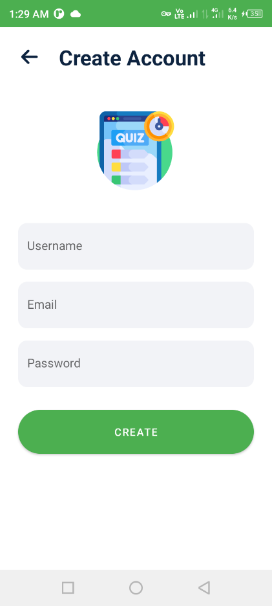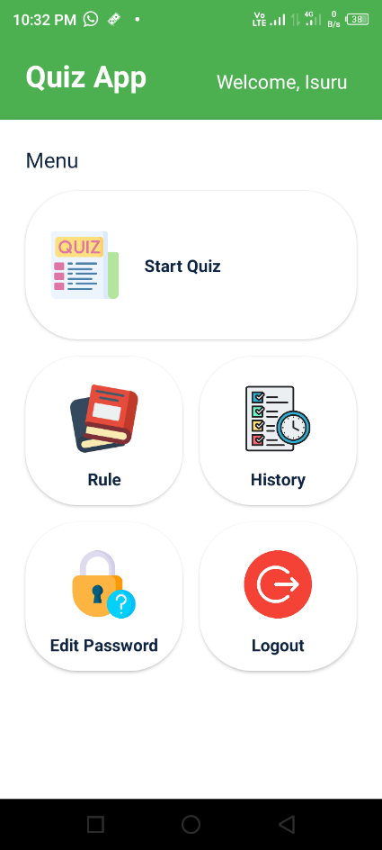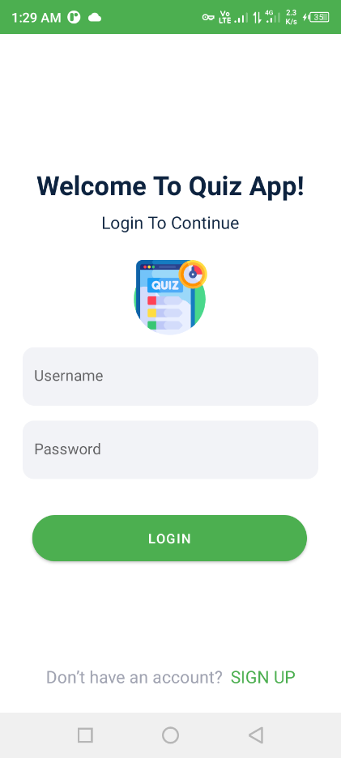

Quiz1

Quiz Option

Main Page

Register

Login

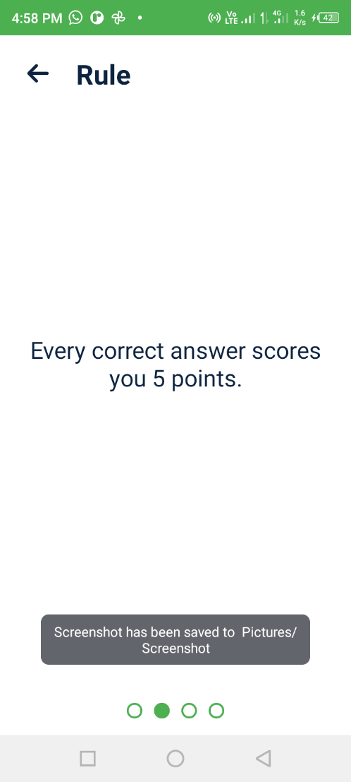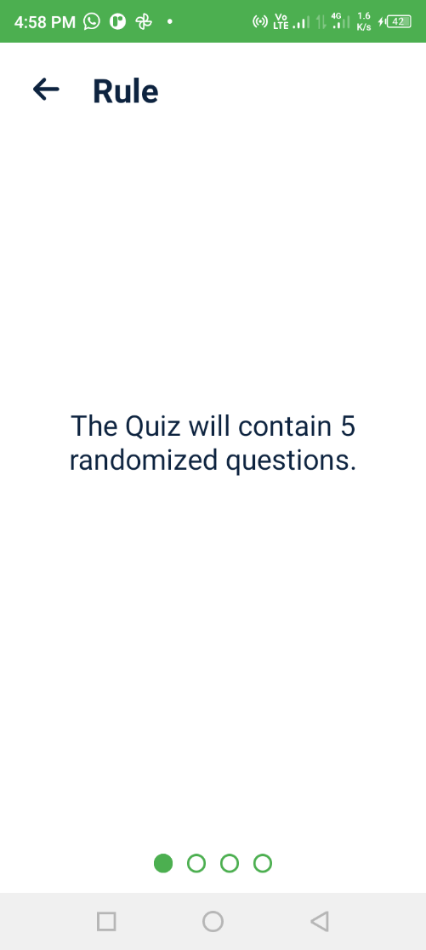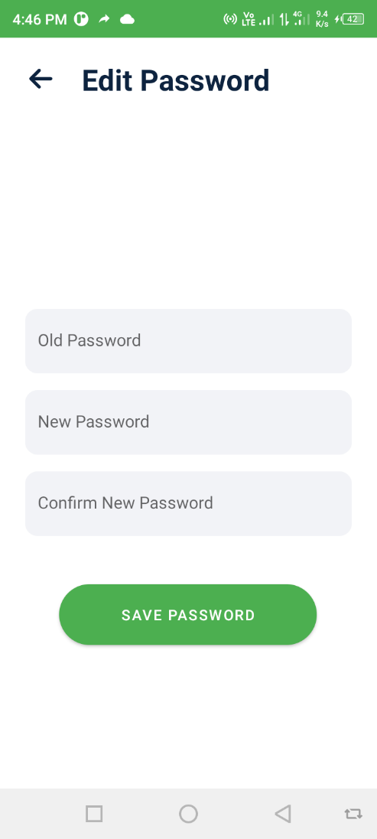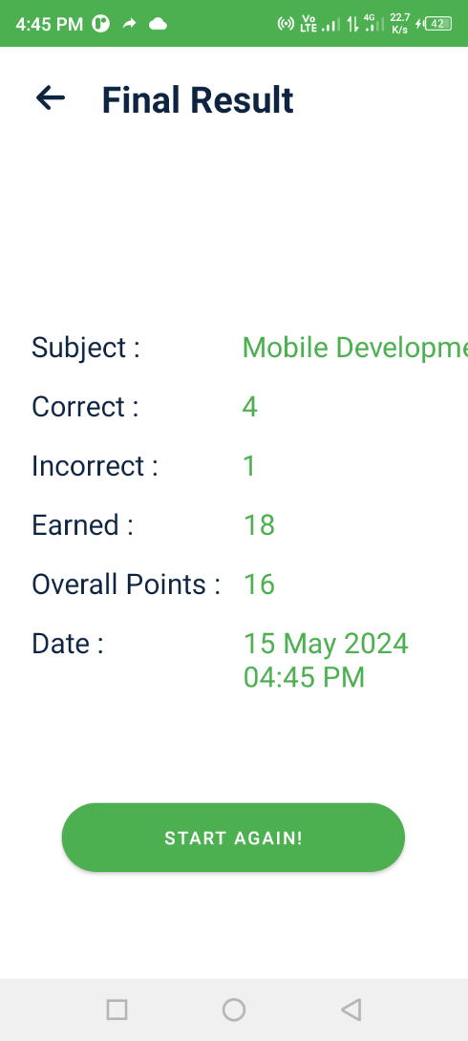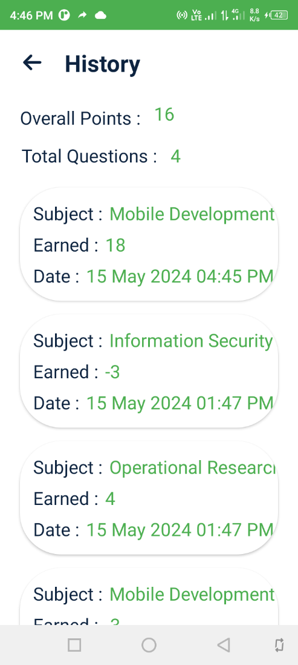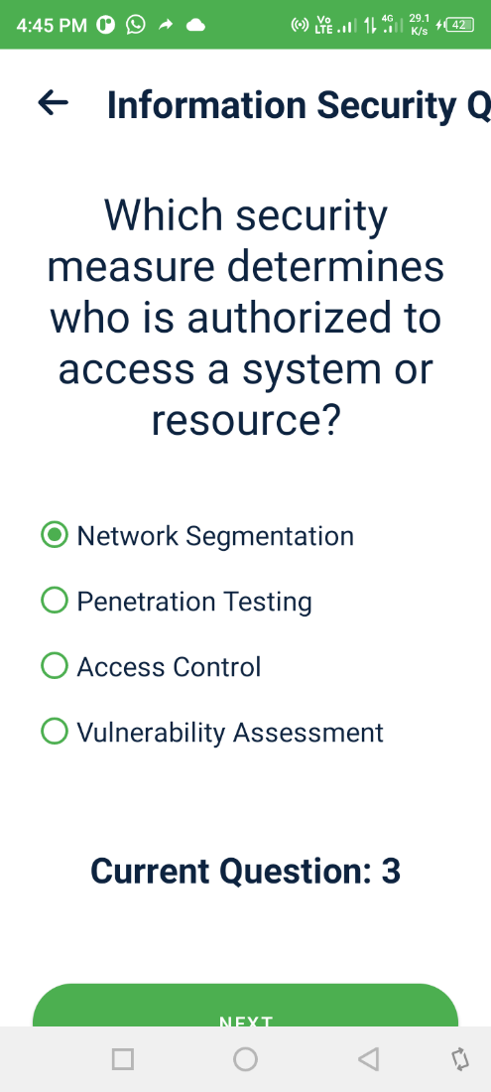

Final Result

History Quiz

Rule 2

Rule 1

Edit Password

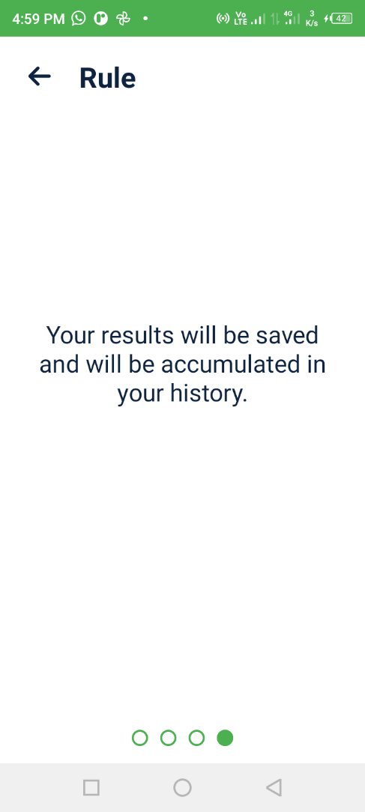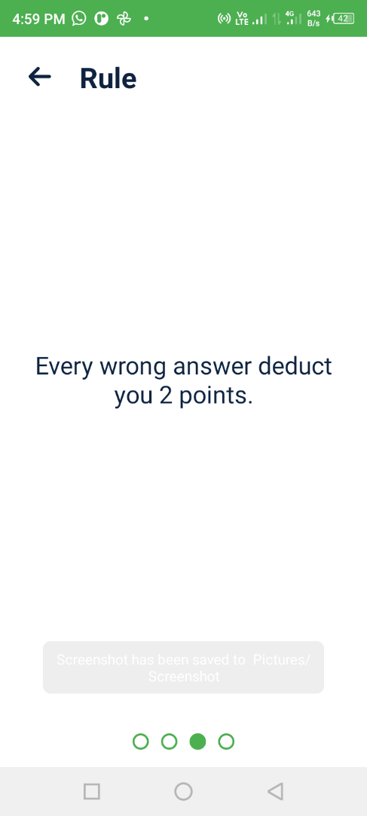

Rule 4

Rule 3